Milestone 3
Create onChange Client Script

Objective
Create an onChange Client Script that automatically sets Urgency to High when Impact is changed to High.

Activity 1 – Create Client Script
- Navigate to System UI → Client Scripts.
- Click New.
- Configure the Client Script.
- Paste the script into the Script field.
- Click Submit to save the Client Script.
- Open an Incident and change Impact to High to verify the behavior.

Client Script Configuration
- Name: Auto set urgency for high impact
- Table: Incident
- Type: onChange
- Field name: Impact
- Active: true

Script
function onChange(control, oldValue, newValue, isLoading) {
if (isLoading || newValue == '') {
return;
}
if (newValue == '1') {
g_form.setValue('urgency', '1');
g_form.addInfoMessage('Urgency set to High for High impact incident.');
}
}

Expected Result
When Impact is changed to High, the Urgency field is automatically set to High and an informational message is displayed.
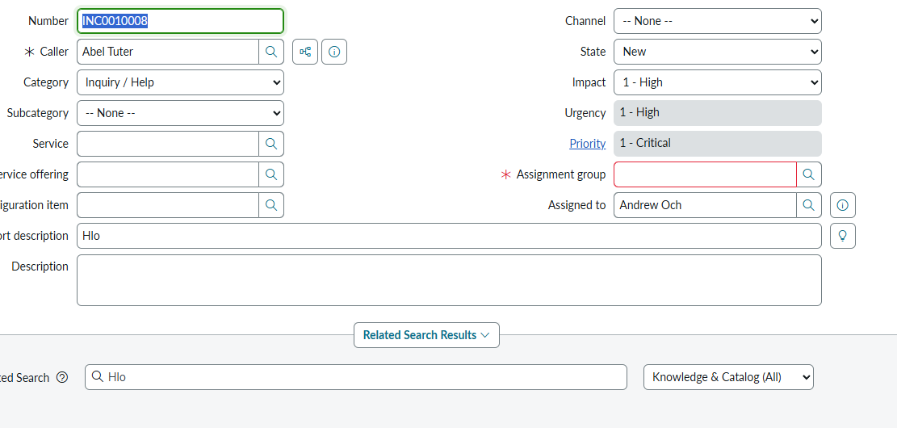
Place the screenshot showing the Client Script configuration here in the final documentation if desired.

